

**UNIVERSITY OF PETROLEUM & ENERGY STUDIES**

**SCHOOL OF COMPUTER SCIENCE**

***Department of Cybernetics***

**GRAPHICS AND ANIMATIONS TOOLS**

**LAB FILE**

**SESSION (2020-21)**

**Course: B.Tech with specialization in Open Source & Open Standards**

**Submitted to:**  **Submitted by:**

Dr. Durgansh Sharma Ashish Pandey

Associate Professor SAP: 500063104

Department of Cybernetics Roll no: R100217014

**Experiment 1**

**Aim:** Installation of GIMP and Blender

**GIMP Installation:**

Step 1: Visit [www.gimp.org](http://www.gimp.org) and install the latest version available for GIMP. Also, check your system compatibility. (GNU Image Manipulation Program)

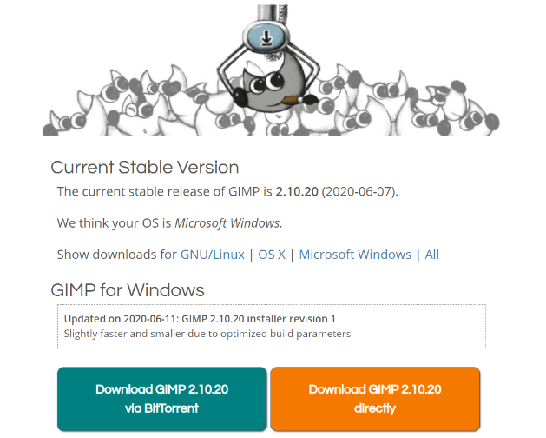

Step 2: After downloading the package, Install GIMP 2.10 using the setup wizard.

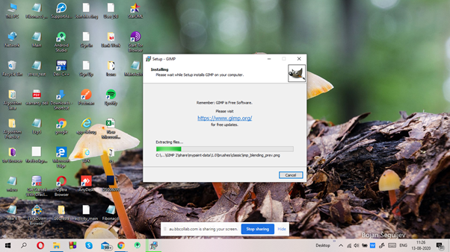

Step 3: Wait till the software is installed.

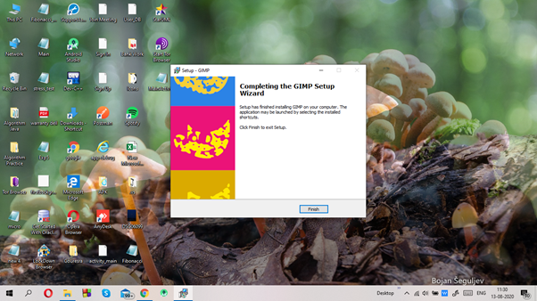

Step 4: Get started with GIMP.

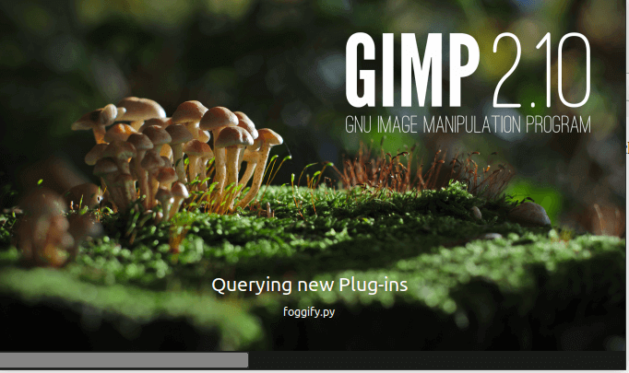

Step 5: The user interface of GIMP

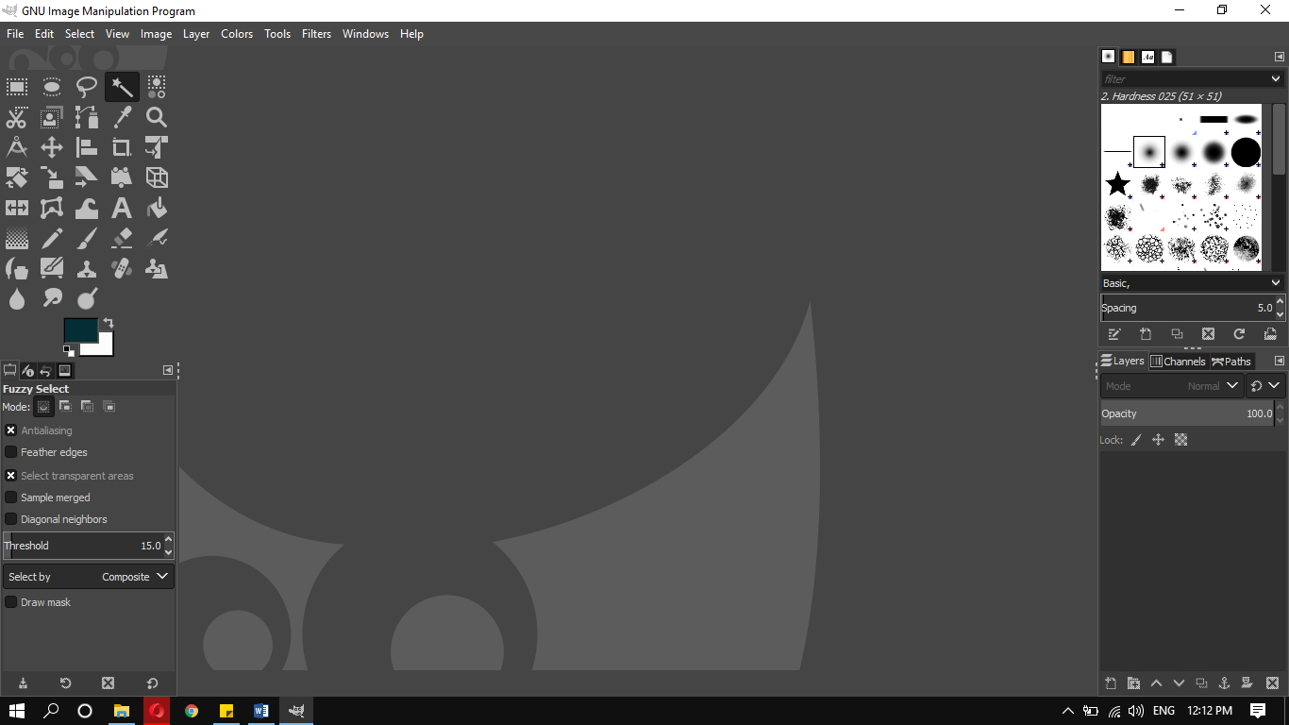

**Blender Installation:**

Step1: Visit [www.blender.org/download](http://www.blender.org/download) and install the latest version available for Blender. Also, check your system compatibility.

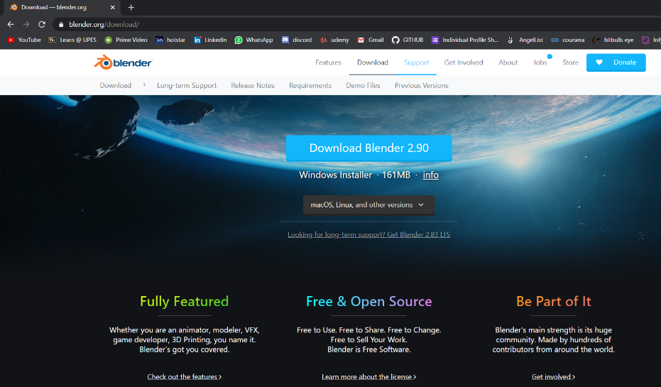

Step 3:Now, Run the downloaded Installer which will probably be available in the download folder.



Step 7: Wait for the Program to Install Blender.

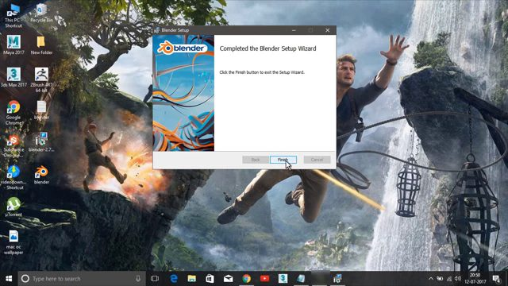

Step5: Get started with Blender.

